|  |  |
| --- | --- |
| 25/09/21  AFPS Alsace | [RetourSiteAFPS-Alsace.jpg](http://www.afps-alsace.com/ressources/0500-Films/01-films_Sommaire.htm)[Scan019.jpg](https://www.facebook.com/sharer.php?u)[Scan018.jpg](https://twitter.com/intent/tweet/)Le genou d’Ahed  de Nadav Lapid  Un film àvoir |

France 24

[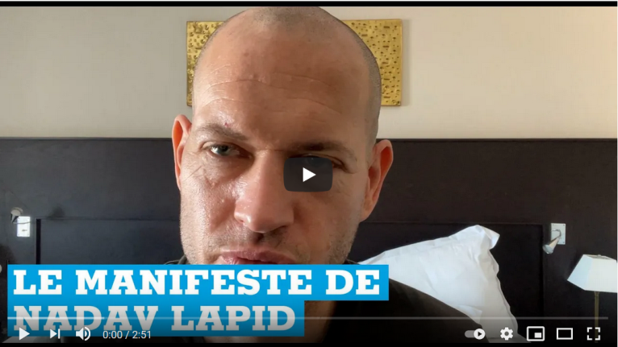](https://www.youtube.com/watch?v=-ERTNAaDp5I&ab_channel=FRANCE24)

Bande Annonce

[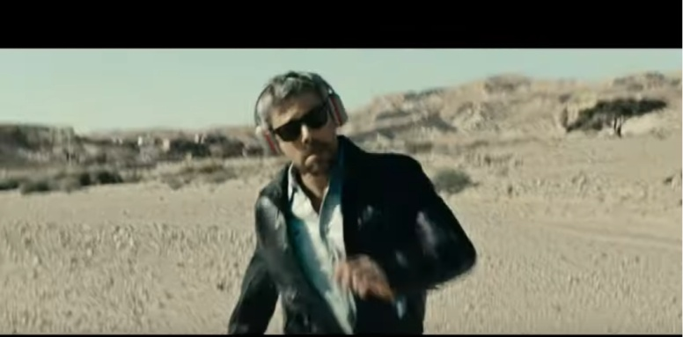](https://www.youtube.com/watch?v=IBbbKM9N4wk&ab_channel=LesInrockuptibles)

Actuellement :

[Cinéma Bel Air - Mulhouse](https://www.google.com/search?q=cin%C3%A9ma+bel+air+le+genou+d%27Ahed&sxsrf=AOaemvIK-iaRSvSPbNhw6r8BKOlVYUjAZA%3A1632574309371&source=hp&ei=ZRtPYbPUE4SC9u8P9qKB6AI&iflsig=ALs-wAMAAAAAYU8pdZSJTSxxDoDBsMuzgPm7CryY6o4z&oq=cin%C3%A9ma+bel+air+le+genou+d%27Ahed)

[Cinéma le sélect à Sélestat](https://www.google.com/search?q=cin%C3%A9ma+le+s%C3%A9lect+S%C3%A9lestat+le+genou+d%27Ahed&sxsrf=AOaemvKZaq47JQBcOxX0K14Yqyd08CMVOA%3A1632574328725&ei=eBtPYbWzK-2D9u8Pg_qdqAE&oq=cin%C3%A9ma+le+s%C3%A9lect+S%C3%A9lestat+le+genou+d%27Ahed&gs_lcp=Cgdnd3Mtd2l6)

[Cinémas Strasbourg et Obernai](https://www.allocine.fr/seance/film-273911/pres-de-112664/d-5/)